|  |  |
| --- | --- |
| Status | In Progress |
| Comments |  |

CABINET CREATION

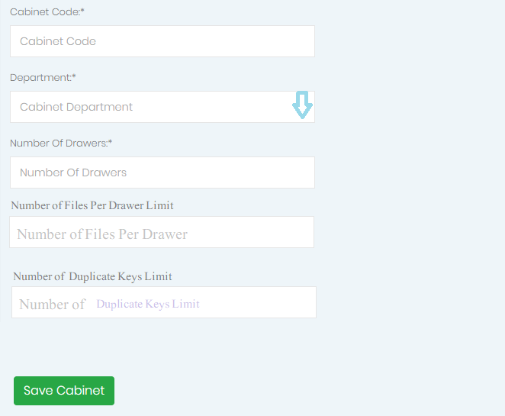

* cabinet code department + digit e.g (C-Finance-01)
* during cabinet creation drawers will be automatically created as specified by Number of Drawers Column.
* After Cabinet creation number of drawers can’t be removed, only add a drawer. But remember in real world scenario one cabinet has not more than 10 drawers.
* Also set number of files limit per drawer. Files cant be exceeded
* Only Admin / Attendant can create Cabinet, User can’t create cabinet.
* Attendant can view cabinet
* Admin can view cabinet/drawer/files.
* Log must be maintained.